**TSTP Manipulation of user and data attributes (2.3.A.4 CSR)**

<DUT Details: > Ex: Router

<DUT Software Version:>

<Digest Hash of OS>

<Digest Hash of Configuration>

<Applicable ITSAR: >

<ITSAR Version No:>

<OEM Supplied Document list: >

1. **<ITSAR Section No & Name>**  **Section 1: Authentication**
2. **<Security Requirement No & Name > 2.3.A.4 Manipulation of user and data attributes**
3. **<Requirement Description: >**

User and data attributes and policy information used by access controls shall not be manipulated by end users unless specifically authorized.

[Ref: OWASP ISVS 4.1.2]

1. **DUT Confirmation Details**:

Smart energy meter model no MB074TI

1. **DUT Configuration:**

Smart energy meter model no MB074TI

1. **Preconditions**
2. One DUT (Smart energy meter)
3. The tester has privilege to create an interactive session between the end user and the supplier both locally and remotely.
4. The vendor should specify the mechanism for hardware tempering.
5. **Test Objective**: The main objective of this test is to ensure the security of the information entered by the user and authorized to a particular admin.

8. **Test Plan:**

**Objective:** To validate the functionality and integrity of user management system by ensuring correct addition of users, authorized modifications, and proper restriction handling.

**Test Scenarios:**

1. **Add Users:** Verify users are added with correct details and roles, including edge cases (empty fields, special characters).
2. **Self-Email Update:** Ensure users can only update their email and no other attributes.
3. **Authorized Attribute Changes:** Confirm that only users with 'admin' or 'superuser' roles can change any attribute of any user.
4. **Unauthorized Access:** Validate that unauthorized users cannot modify attributes they are not permitted to.

**Steps:**

1. Add multiple users interactively.
2. Attempt to change email as a non-admin user.
3. Modify attributes using an admin account.
4. Validate final user details.

**Expected Results:**

* All operations should comply with role-based access rules and input constraints

**TEST CASES:** No. of Candidates 🡪 2

User🡪Thomas, Admin🡪Edward (User is allowed to change email only, while Admin is allowed to change details of any user according to requirement).

***PHYTHON CODE SCRIPT:***

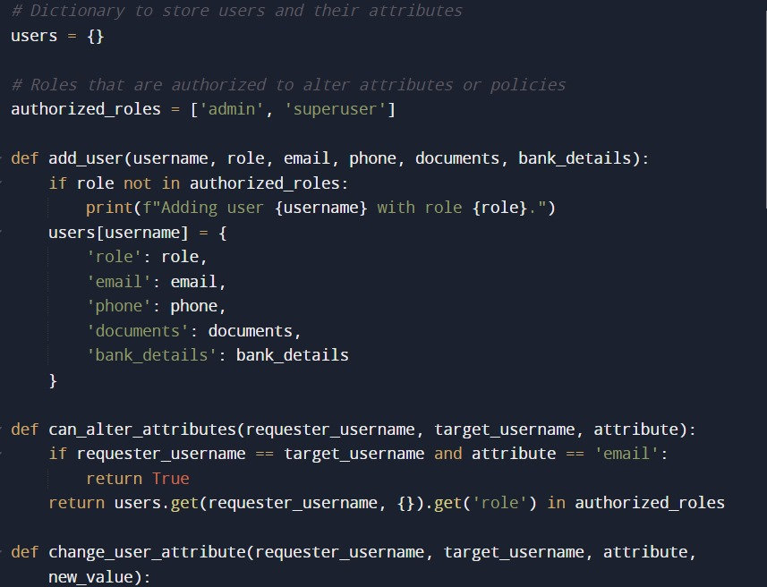

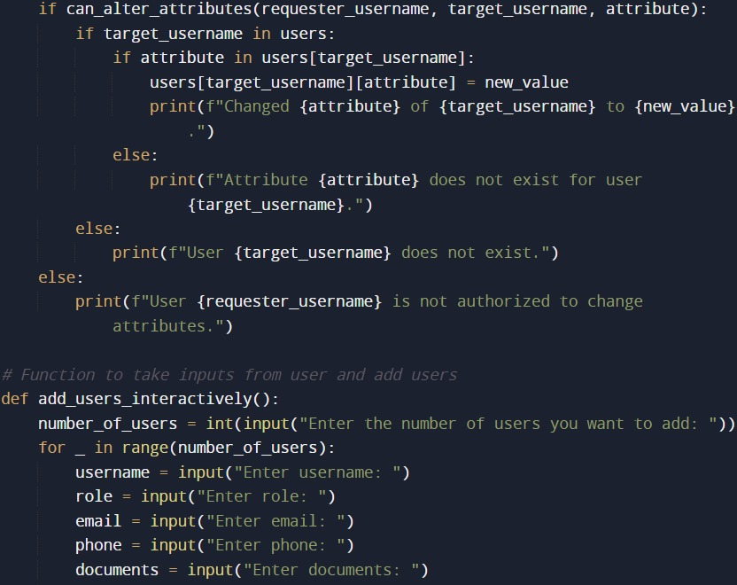

***Figure: 1.1 (continue down fig 1.2)***

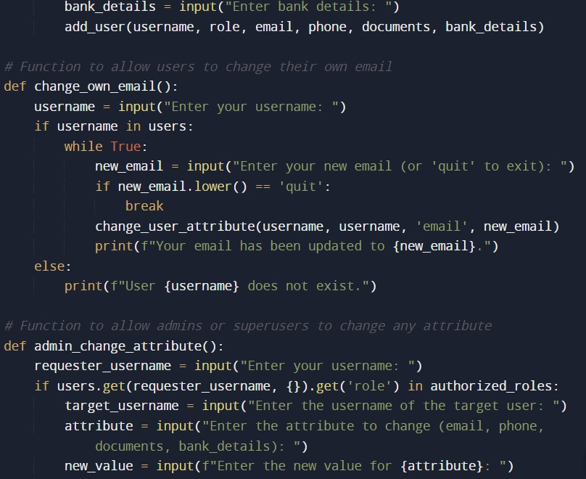

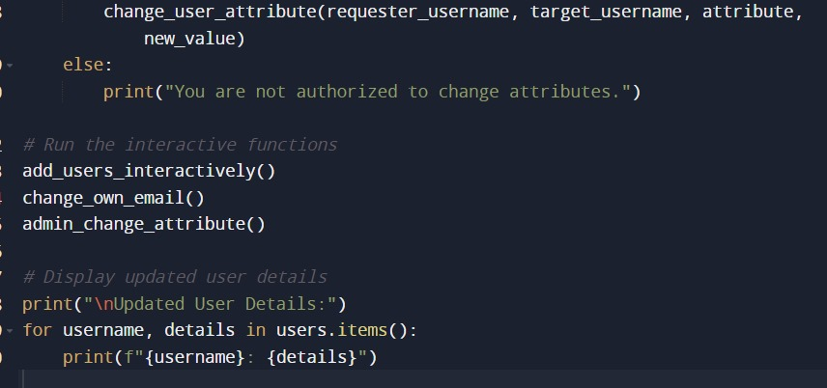

***Figure 1.2: (Code complete here)***

* ***OUTPUT OF TEST CASES:***

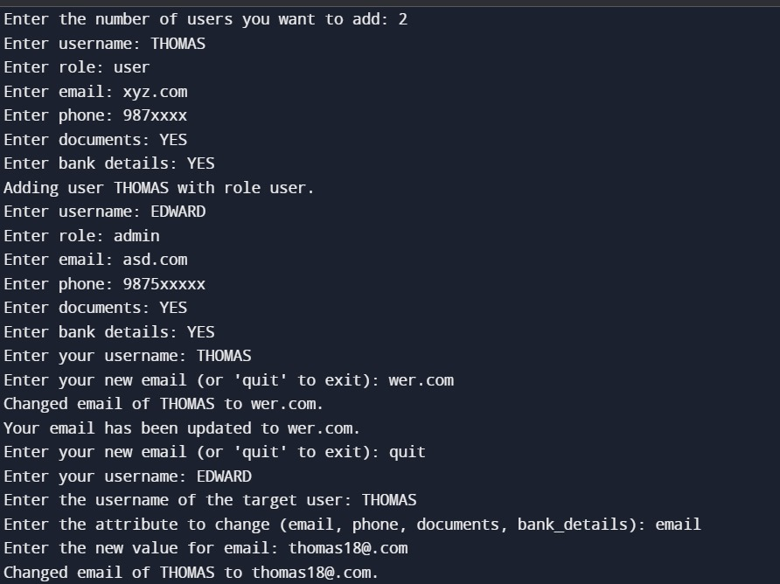

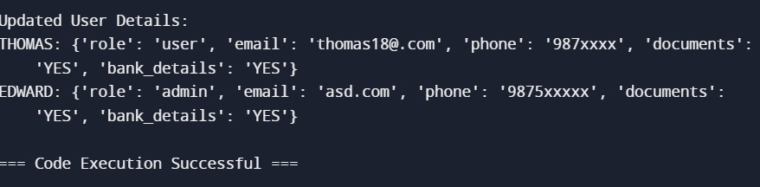

***Figure 1.3: Code Execution Successfully Completed. With Expected Result!***